**Ideation Phase – Empathize & Discover**

**Project Name: Garage Management System**

**Team ID**: LTVIP2025TMID31528

**College Name: Ideal Institute Of Technology**

**Objective:**

To understand the real needs, challenges, and pain points of garage users (owners, technicians, and customers) to create a user-focused management system.

**Key Stakeholders:**

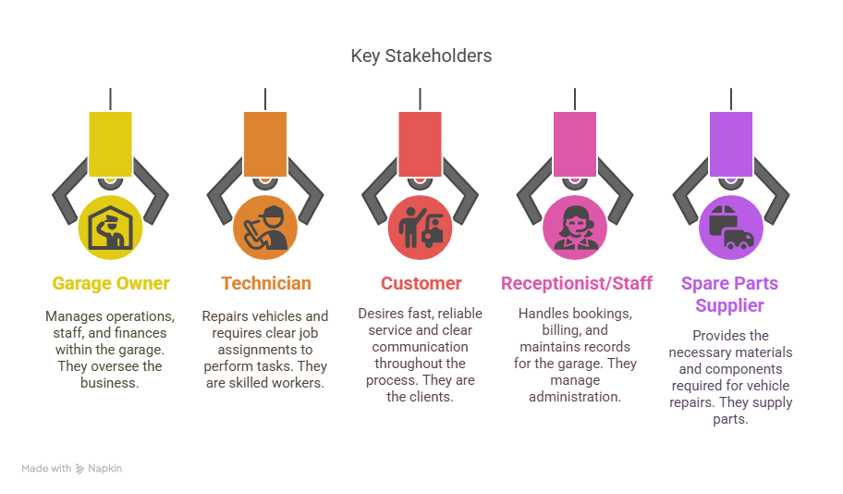

**Empathy Highlights:**

**Garage Owner:**

* **Needs**: Organized operations, easy monitoring
* **Pain Points**: Paperwork, inaccurate billing, staff tracking

**Customer:**

* **Needs**: Timely updates, transparency in service & charges
* **Pain Points**: No service status info, unclear bills

**Technician:**

* **Needs**: Service history access, tool availability
* **Pain Points**: Delays due to missing parts, manual records

**Key Discoveries:**

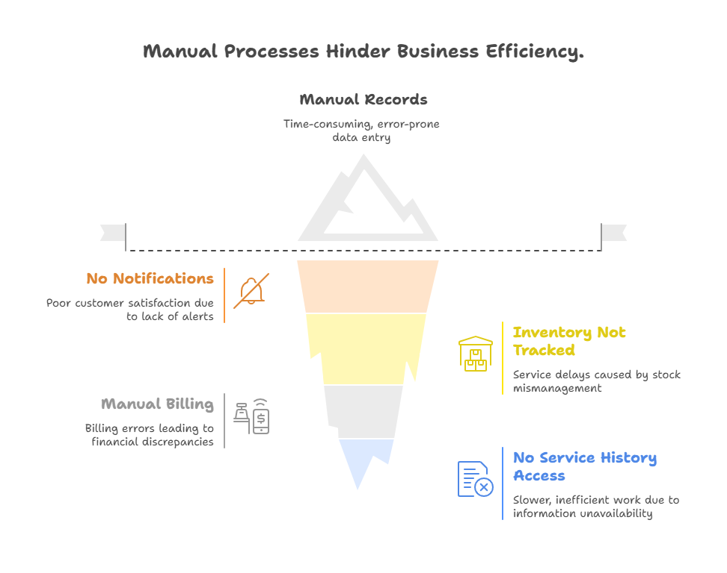

**Conclusion:**

Empathizing with users reveals a strong need for a **digital, automated system** that improves service tracking, inventory, billing, and communication — making garage operations **faster, smarter, and customer-friendly**.